Table of Contents

Project Name: Microsoft Movie Studio Market Research and Strategy 2

1.0 OVERVIEW 2

1.1 Background of the business 2

1.2 Domain of the business 2

2.0 BUSINESS UNDERSTANDING 3

2.1 Problem 3

2.2 Objectives 3

3.0 DATA UNDESTANDING 3

3.1 Relation of our datasets 3

i. Movie Title: 3

ii. Genre: 3

iii. Production Company: 3

3.2 Data Cleaning 4

a) Handling missing data: 4

b) Checking for duplicates: 4

c) Data type conversion: 4

d) Outlier detection: 4

e) Standardizing data: 4

f) Removing irrelevant columns: 4

4.0 DATA ANALYSIS 5

4.1 Univariate Analysis 5

1) Identify the most popular genres in terms of the number of movies released. 5

2) The distribution of number of movies produced by different production companies. 5

4.2 Bivariate Analysis 6

1) Comparing the foreign gross and domestic gross from movies over the years. 6

5.0 CONCLUSION AND RECOMMENDATION 7

5.1 Conclusion 7

5.2 Recommendations 7

i. Recommendation for Film Types: 7

ii. Production Strategies: 7

# Project Name: Microsoft Movie Studio Market Research and Strategy

# 1.0 OVERVIEW

Recognising the dynamic shift in the entertainment industry, where big organisations have made tremendous progress in the creation of unique video content, Microsoft is starting a brand-new fascinating endeavour. Microsoft has made the decision to enter the film production industry strategically, leveraging its impressive technological prowess and resources. This choice demonstrates the firm's dedication to diversifying its holdings and keeping up with shifting consumer tastes. Despite being a major player in technology, Microsoft recognises the value of gaining expertise and experience in the film industry. Microsoft wants to get a thorough understanding of the current trends and audience preferences that influence box office success in order to assure a successful entry. Microsoft is positioned to have a huge impact on the world because to its commitment to informed decision-making and enthusiasm for innovation.

## 1.1 Background of the business

Leading major global technology company Microsoft has noticed the trend of big businesses effectively breaking into the original video content creation industry. As a result of this, Microsoft has made the strategic decision to launch its own film production company after observing the success of major corporations in this industry. Microsoft, however, lacks the knowledge and experience needed in the movie business. The business wants to comprehend the current trends and preferences influencing box office success in order to make wise selections and guarantee a successful entry.

## 1.2 Domain of the business

This company's area of expertise is at the nexus of entertainment and technology. Microsoft, famed for its software, hardware, and cloud services, is attempting to join the highly competitive and creative world of cinema by utilising its resources and technological skills. Consumer preferences are rapidly changing, distribution methods are changing, and creative narrative is required in the film industry.

# 2.0 BUSINESS UNDERSTANDING

## 2.1 Problem

Microsoft's new movie studio lacks insights into the movie industry's trends and audience preferences, hindering its ability to make informed decisions regarding the types of films and movies to produce. In order to be successful in the new venture they require to have answers to questions such as;

1. Most popular genre?
2. Most rated /watched genres by audiences?
3. Which languages are movies mostly produced in?
4. What is the gross income of movies over the years?
5. What is the best runtime for movies?

## 2.2 Objectives

1. To identify the most popular/ most produced genres of movies.
2. To analyse the best runtime for movies.
3. To identify which languages are most movies produced in.
4. To analyse the gross income of movies over the years.
5. To identify genres with the highest runtime

# 3.0 DATA UNDESTANDING

## 3.1 Relation of our datasets

After gathering the data, we need to understand the columns and their meanings and how they relate in our datasets. Common columns in our datasets include:

### Movie Title:

This is the name of the film. In our datasets these columns include: original title, primary title, title.

### Genre:

This category or type of the movie (e.g., action, comedy, drama). In our datasets this column is under the name genres.

### Production Company:

The company responsible for producing the movie. In our dataset this column is under the name studio.

## 3.2 Data Cleaning

Data cleaning is essential to ensure that the datasets are accurate and suitable for analysis. Steps I followed include:

### Handling missing data:

Removed the null values in some of the columns that were minimal and could not affect our datasets. Also, imputing the missing values in a certain column and replaced it with values since the number of null values were too many to drop and doing so would have affected our datasets.

### Checking for duplicates:

Eliminate duplicate entries ensures that our datasets do not have duplicate data.

### Data type conversion:

Ensure data types are appropriate for analysis whether string, integer, date time etc.

### Outlier detection:

Identifies and handles outliers in gross and other numerical columns.

### Standardizing data:

Ensures there is consistency in column names and values.

### Removing irrelevant columns:

Remove any columns that do not contribute to the analysis.

# 4.0 DATA ANALYSIS

Data analysis summarizes collected data. It involves the interpretation of data gathered through the use of analytical and logical reasoning to determine patterns, relationships or trends, performing exploratory data analysis (EDA) to gain insights into the data. Some possible analyses and visualizations include:

## 4.1 Univariate Analysis

### Identify the most popular genres in terms of the number of movies released.

From the dataset I was able to plot a bar graph to show the distribution of movie genres as follows:

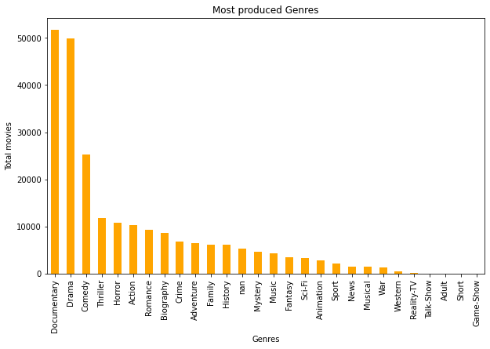

### The distribution of number of movies produced by different production companies.

From the dataset I was able to plot a bar graph to show which studios have produced the most number of movies. This is shown in the graph below:

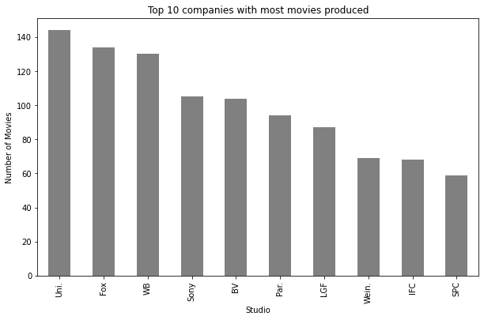

## 

## 4.2 Bivariate Analysis

### 1) Comparing the foreign gross and domestic gross from movies over the years.

From the data set I was able to plot a line graph comparing the two and output was as below:

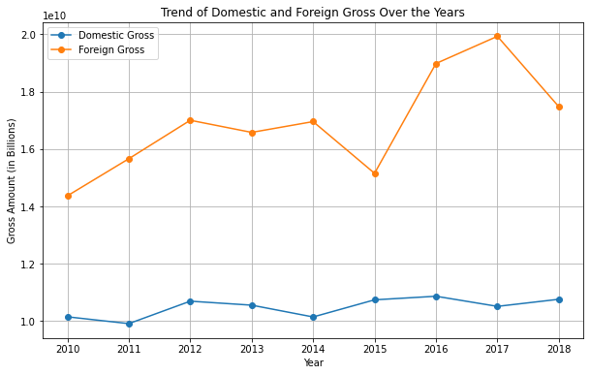

# 5.0 CONCLUSION AND RECOMMENDATION

## 5.1 Conclusion

To enter the film industry successfully, Microsoft's new movie studio should create a diverse portfolio of films within these recommended genres, carefully manage budgets, and prioritize audience satisfaction. Additionally, building strong relationships with industry professionals and leveraging Microsoft's existing resources and technologies can enhance their competitive edge.

By conducting this comprehensive EDA and generating insightful plots, the head of Microsoft's new movie studio can make informed decisions about the types of films to create, the runtime minute for movies and films and other production strategies to maximize their success in the competitive film industry.

## 5.2 Recommendations

## Recommendation for Film Types:

Based on the analysis, the most produced genre is documentaries followed by drama, comedy etc. This means that most audience watch these genres compared to the others. I would recommend that Microsoft should produce more films of the named genres.

## Production Strategies:

Also I would recommend collaborating with successful production companies or studios based on their track record. From the analysis, universal studio has produced more movies compared to other studios while BV studios has made the highest total gross both domestic and foreign.